Property Registration System

Revision Number: 1.0

Last date of revision: 06/12/2021

### Team Members

Ameya Ambike B2020066

Partha Gautam B2020095

Rithik Rai B2020104

Tejas Rajebhosale B2020102

Shubham Srivastava B2020117

Varsha Satpathy B2020122

# Document Version Control

|  |  |  |  |
| --- | --- | --- | --- |
| Date Issued | Version | Description | Author |
| 31/10/2021 | 1 | Initial HLD — V1.0 | Shubham Srivastava |
| 25/11/2021 | 2 | HLD-V2.0 | Varsha Satpathy |
| 25/11/2021 | 3 | LLD-V1.0 | Partha Gautam |

Contents

Team Members 1

Document Version Control 2

**1** General Description 4

1 Introduction 7

1.1 What is a low level design document? 7

1.2 Scope 7

2 Architecture 8

3 Architecture Description 8

3.1 Registration Details Input 8

3.2 Storage in local database 8

3.3 Data transferred to verification agency 8

3.4 Agency to the government 8

3.5 Mining a block 9

3.6 Proof of Work 9

3.7 Adding data to block 9

3.8 Adding to the blockchain 9

3.9 Broadcasting the updated blockchain 9

Abstract:

The current property registration system is riddled with inconsistencies and inefficiencies, resulting in a lack of protection for property records, with citizens bearing the brunt of the burden. Similarly, tens of thousands of others are facing a similar crisis. With the help of Blockchain, all documents can be stored indefinitely, are easily accessible, and no one can ever doubt the authenticity of the data because they are constantly supplied into the system. As a result, no one can ever change it, and any participant can view the records at any moment. In fact, because of Blockchain's transparency, it's possible to follow changes made in property records.

### General Description

#### Product Perspective

The focus of real estate technology has typically been on listings and connecting buyers and sellers. However, blockchain has the potential to bring new ways to trade real estate and to enable trading platforms and online markets to more thoroughly support real estate transactions. The real estate ecosystem has traditionally included brokers, lawyers, and banks. However, blockchain has the potential to change their roles and involvement in real estate transactions. Listings, payments, and legal documents are all functions that new platforms could someday take over. By eliminating intermediaries, buyers and sellers will get better value for their money because they will save on commissions and fees charged by these intermediaries. This also speeds up the process by eliminating the back-and-forth between these middlemen.

* 1. Problem statement

To create a Property Registration System that will help:

* + - To create a unified platform for marketplaces
    - To eliminate the extra cost of intermediaries
    - To increase the liquidity of real estate business
    - Push the concept of fractional ownership
    - Decentratization to improve trust and security
  1. Tools used

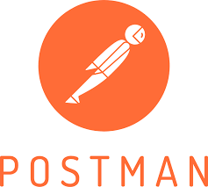

* + - Python:It is an interpreted, object-oriented, high-level programming language used as a support for software developers, for build control and management, testing, and in many other ways
    - Postman: It is an interactive and automatic tool for verifying the APIs of a project.
    - Spyder: It is an open-source cross-platform IDE, written completely in Python.

1.4 Steps Required to develop Property Registration System:

* Create a basic architecture of registration system interaction or flowchart how functions will interact with each other.
* Development can be started using any development tools like Truffle, remix with proper documentation of each and every function.
* Once the development is completed start testing the system on test-net or private blockchain.
* Unit testing will be the next step in the development life cycle. Once the unit testing is done using framework, the system author should go for 3rd party audit of the same.

1.5 Hardware Requirements

* Intel Core i7(6th Gen or Higher)
* Atleast 8 GB RAM.
* 500 GB Hard Disk.
* A stable internet connection (2mbps or higher)
  1. Error Handling

Errors should be encountered; an error message will be displayed as to what went wrong. An error will be defined as anything that falls outside the normal and intended usage

1. Performance

#### Reusability

The code written and the components used should have the ability to be reused with no problems.

#### Application Compatibility

The different components for this project will be using Python as an interface between them. Each component will have its own task to perform, and it is the job of the Python to ensure proper transfer of information.

#### Resource Utilization

When any task is performed, it will likely use all the processing power available until that function is finished.

#### KPls (Key Performance Indicators)

1. It should maintain the proper cycle time.
2. It should include value assessment.
3. It should also consider geographic market expansion.
4. It should contain new account acquisition metrics.

Low Level Design

# Introduction

## What is a low level design document?

The purpose of a low level document is to explain the granular level working of the Blockchian based KYC verification processing. The low level design document contains all the modules that will be used while programming. The document contains the diagram of the flow of the program as well as the description of each module. This facilitates the programmer to have a clear understanding of the modules they are working for.

## Scope

The document necessarily covers the program flow and the sequences in which the modules function. This process can be used for designing the data structures, for software architecture and the source code. This document does not include the various modules that can be further linked to provide additional functionalities.

# Architecture

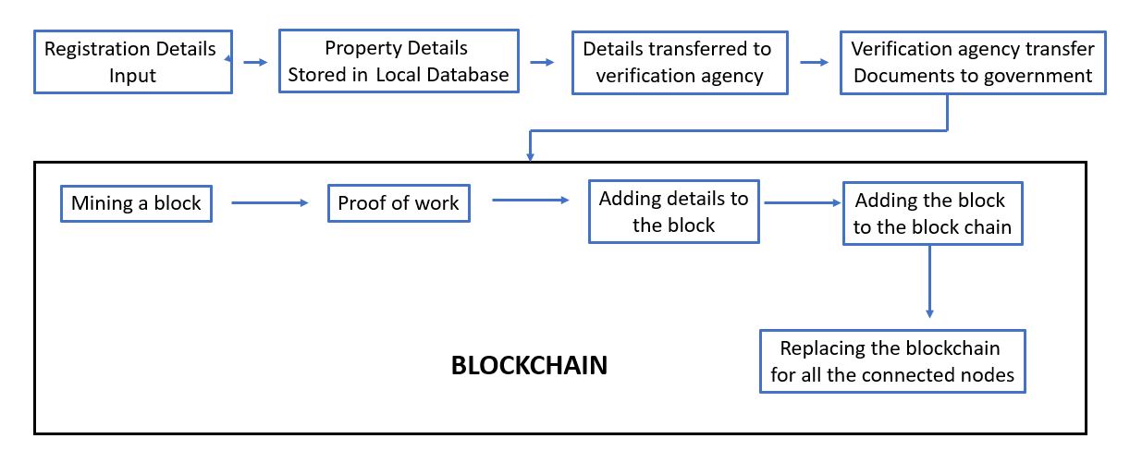

*Figure 1: Program Flow Architecture*

# Architecture Description

## Registration Details Input

The first step is to input owner, buyer and property details to the Property Registration System portal. The customer use this portal when he/she buys a property from a land owner.

## Storage in local database

The uploaded details get stored in the local database. The real estate agency maintain these databases only for the temporary storage of the customer’s files.

## Data transferred to verification agency

In this stage, the real estate agency transfers the documents to an external verification agency. The external verification agency will perform the physical verification of the owner, buyer, property details etc.

## Agency to the government

Once the external verification agency completes the verification, they authenticate and certify the verification done and transfer the verified data to the government.

## Mining a block

It is the process of finding a nonce which satisfies the HASH restrictions. In this architecture, the government is assumed to be the one’s building and maintaining the blockchain. Once the verified data is received by the government, they mine a block with the requisites.

## Proof of Work

While mining a block, once the hashkey is generated, the hashkey is verified for the predetermined sequence. If the condition is satisfied, the proof of work is complete. If not, the hashkey is again generated.

#### Algorithm for Hashing: SHA – 512

SHA 512 has 128 characters as compared to SHA 256 with 64 characters. The reason for choosing SHA-512:

* + - It is faster than SHA-256 on 64-bit machines is that has 37.5% less rounds per byte (80 rounds operating on 128 byte blocks) compared to SHA- 256 (64 rounds operating on 64 byte blocks)
    - It is more secure than SHA 256

## Adding data to block

Once the proof of work is completed successfully, the verified data are added to the block.

## Adding to the blockchain

Once the block is created successfully, the block will be added by the government to the blockchain.

## Broadcasting the updated blockchain

The updated blockchain is now being broadcast to all the nodes (real estate agencies) in the network. This is done by replacing the blockchain of all the nodes with the new blockchain along with the added block.

If an agency wants to get integrated to the blockchain, then an add node module is used to add the node to the blockchain network.

#### Conclusion

The objective of Property Registration is to satisfy common contractual conditions. The goal is to simplify business and trade between both anonymous and identified parties. It also aims to lower the cost as there are no intermediaries or cost fees during the execution process.